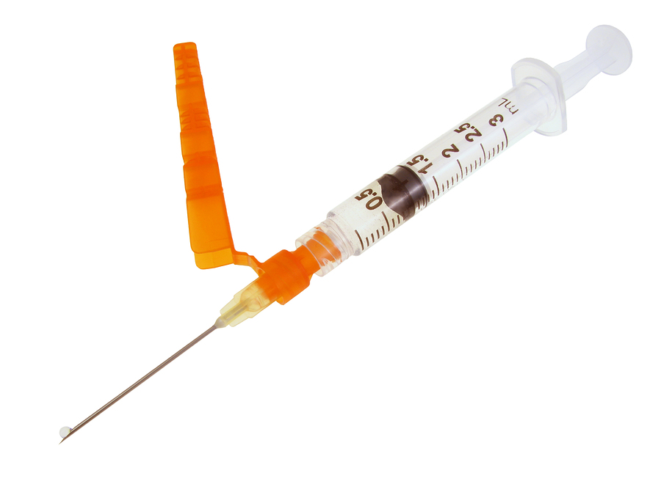
Improper handling and disposal of needles and other sharps, including scalpels, broken glass, and razors, can result in serious infections, such as Hepatitis B virus (HBV), Hepatitis C virus (HBC) and the Human Immunodeficiency Virus (HIV), which causes AIDS.
There are many precautions that must be taken to limit exposure. Follow universal precautions by treating all blood and other bodily fluids as if they are contaminated with bloodborne pathogens.
Personal protective equipment (PPE):
- When in potential exposure situations, wear the proper PPE, such as liquid and puncture resistant gloves and a face mask.
- Immediately replace PPE that has been compromised or contaminated.
- Properly disinfect or dispose of used PPE and other materials exposed to blood and other bodily fluids.
- Wash hands immediately after removing PPE.
Handling needles and sharps:
- Do not bend or recap used needles and other sharps.
- Do not shear or break contaminated sharps.
- Discard used sharps immediately in an approved sharps container.
Needle alternatives:
Reduce exposure hazard by using needleless or recessed-needle systems:
- Needleless connector systems for intravenous (IV) delivery systems: Such as blunt cannula for use with pre-pierced ports and valved connectors that accept tapered or luer ends of IV tubing.
- Self-sheathing safety feature: Sliding needle shields attached to disposable syringes and vacuum tube holders.
- Retractable technology: Needles or sharps that retract into a syringe, vacuum tube holder, or back into the device.
- Self blunting technology: Self-blunting phlebotomy and winged-steel "butterfly" needles (a blunt cannula seated inside the phlebotomy needle is advanced beyond the needle tip as the needle is withdrawn from the vein).
- Add-on safety features: Hinged or sliding shields attached to phlebotomy needles, winged steel needles, and blood gas needles.
Containers for sharps disposal:
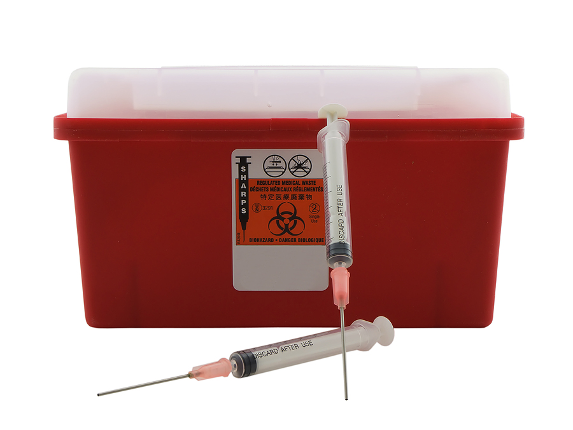
- Containers for used sharps must be puncture-resistant.
- The sides and the bottom must be leak-proof to prevent unintentional contamination.
- Containers must be red or orange in color and carry the proper biohazard labeling.
- Containers must have lids and be positioned upright to keep liquids and sharps inside.
- Containers must not be opened, emptied, or cleaned manually.
- Containers must be located in close proximity to work areas involving sharps, but not placed such that patients and visitors would be at risk.
- Sharps containers must be placed in laundry departments.
- Do not fill sharps containers more than 2/3 full or past the fill line.
- Containers must be replaced regularly.
- When sharps containers are ready to be discarded, close the lid securely.
- If there is a chance of leakage, a secondary container that is closable, labeled, color-coded, and leak-resistant must be used for storage and transport.
- Never put hands into a sharps container.
In the event of an exposure:
If you or another individual is stuck by a needle or other sharp object or get blood or other bodily fluids in your eyes, nose, and mouth or on an open wound, take the following steps and all other steps prescribed in the bloodborne pathogen exposure control plan:
- Immediately flood the exposed area with water and clean any open wounds with soap and water or a skin disinfectant.
- Immediately report the incident to the supervisor.
- Document the kind of injury, route of exposure, and how the exposure occurred in the sharps injury log.
- Obtain consent from the source individual and the exposed employee to perform blood tests as soon as possible.
- Within fifteen days, you and management will be provided a written opinion of blood-test findings.
- If indicated, risk counseling and post-exposure treatment for disease will be offered.

With proper training and engineering controls,
needlesticks and sharps injuries can be prevented.
This form documents that the training specified above was presented to the listed participants. By signing below, each participant acknowledges receiving this training.

Organization:

Trainer: Trainer’s Signature:

Class Participants:

Name: Signature: Date:

Name: Signature: Date:

Name: Signature: Date:

Name: Signature: Date:

Name: Signature: Date:

Name: Signature: Date:

Name: Signature: Date:

Name: Signature: Date:

Name: Signature: Date:

Name: Signature: Date:

Name: Signature: Date:

Name: Signature: Date:

Name: Signature: Date:

Name: Signature: Date:

Name: Signature: Date:

Remember to load your completed trainings into the Risk Management Center.

